**Funkcie tangens a kotangens**

|  |  |  |  |  |  |  |  |  |
| --- | --- | --- | --- | --- | --- | --- | --- | --- |
| **x** |  |  |  |  |  |  |  |  |
|  |  |  |  |  |  |  |  |  |
| **sin x** |  |  |  |  |  |  |  |  |
| **cos x** |  |  |  |  |  |  |  |  |
| **tg x** |  |  |  |  |  |  |  |  |
| **cotg x** |  |  |  |  |  |  |  |  |

Definície funkcií tangens a kotangens:

$tg x= \frac{sin x }{cos x}$ $cotg x= \frac{cos x }{sin x}$

Znamienka funkcií tangens a kotangens:

|  |  |  |  |  |
| --- | --- | --- | --- | --- |
| **kvadranty** |  |  |  |  |
| **v radiánoch** |  |  |  |  |
| **v stupňoch** |  |  |  |  |
| **sin x** |  |  |  |  |
| **cos x** |  |  |  |  |
| **tg x** |  |  |  |  |
| **cotg x** |  |  |  |  |

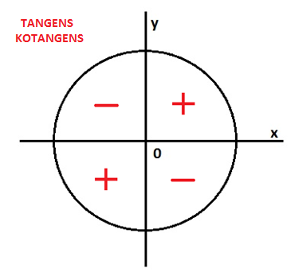

**Graf funkcie y = tg x**

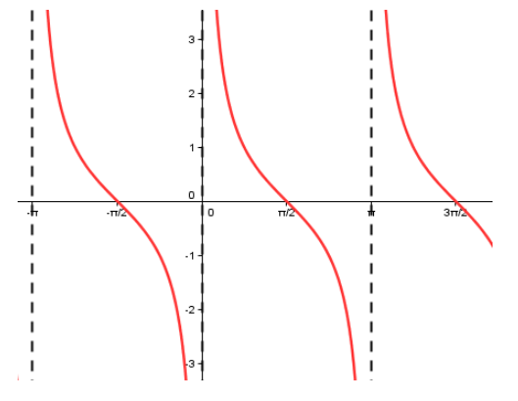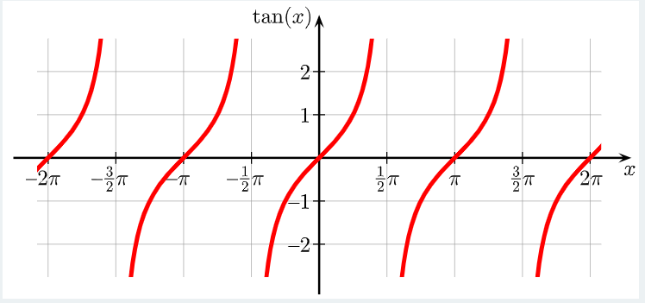

Grafom funkcie y = tg x je **TANGENTOIDA**.

Vlastnosti funkcie TANGENS:

D(f) =

H(f) =

R/K:

P/N:

Ohr.:

Min/Max:

Periodickosť:

**Graf funkcie y = cotg x**

Grafom funkcie y = cotg x je **KOTANGENTOIDA**.

Vlastnosti funkcie KOTANGENS:

D(f) =

H(f) =

R/K:

P/N:

Ohr.:

Min/Max:

Periodickosť: